July 23, 2026

ADDENDUM No. 1
PREQUALIFICATION OF CONTRACTORS
RM-202112
Extra Heavy Duty Towing and Recovery Services on the New Jersey Turnpike and on the Garden State Parkway

Vendors are hereby notified that the Prequalification Application in the above-mentioned procurement is amended and supplemented as follows:

- Per Section III, para. B.1, page 15 of the Prequalification Application, delete the following sentence:
“except for Zone 2 where the Applicant’s garage shall be within seven (7) miles driving distance of such Zone.” This requirement is not applicable to the Prequalification Application for the above-mentioned procurement.

- Per Section III, para. C.4(i), page 16 of the Prequalification Application, add the following language:
“Applicant may satisfy the requirement for one (1) forty (40) yard roll-off dumpster or equivalent size dump truck/dump trailer through the use of an Access Agreement, provided that the Applicant seeks and receives the Authority’s prior written approval of the equipment and of the third party who will provide Applicant with access to the roll-off dumpster or equivalent size dump truck/dump trailer. The agreement between the Applicant and the third-party providing access must be in writing (the “Access Agreement – Equipment”). An acceptable form of Access Agreement – Equipment can be found on Bid Express. A fully executed copy of the Access Agreement – Equipment must be submitted with this Prequalification Application and is subject to review and approval by the Authority.”

- The date for the submission of the Prequalification Application has been changed from August 4, 2026 to SEPTEMBER 8, 2026 (by 3:00 p.m. EST).

Receipt of Addendum No. 1 must be acknowledged on the Bid Express Platform. Failure to acknowledge receipt of this Addendum will be construed as acknowledgement.

Very truly yours,

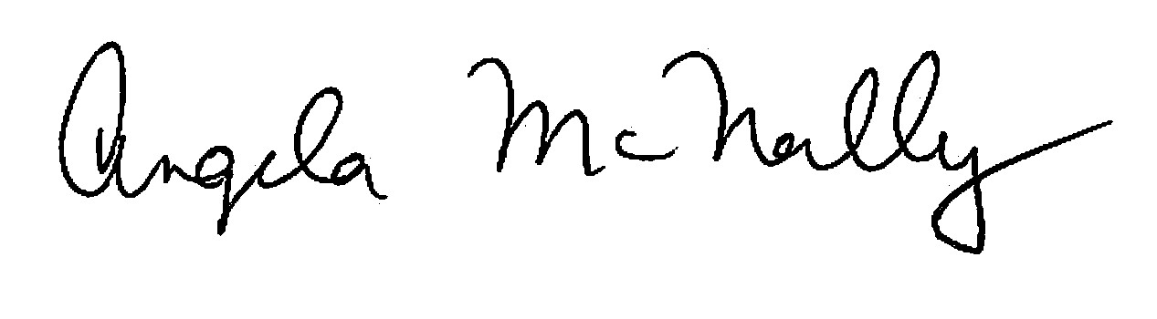

Angela McNally, Director
PMM Department

